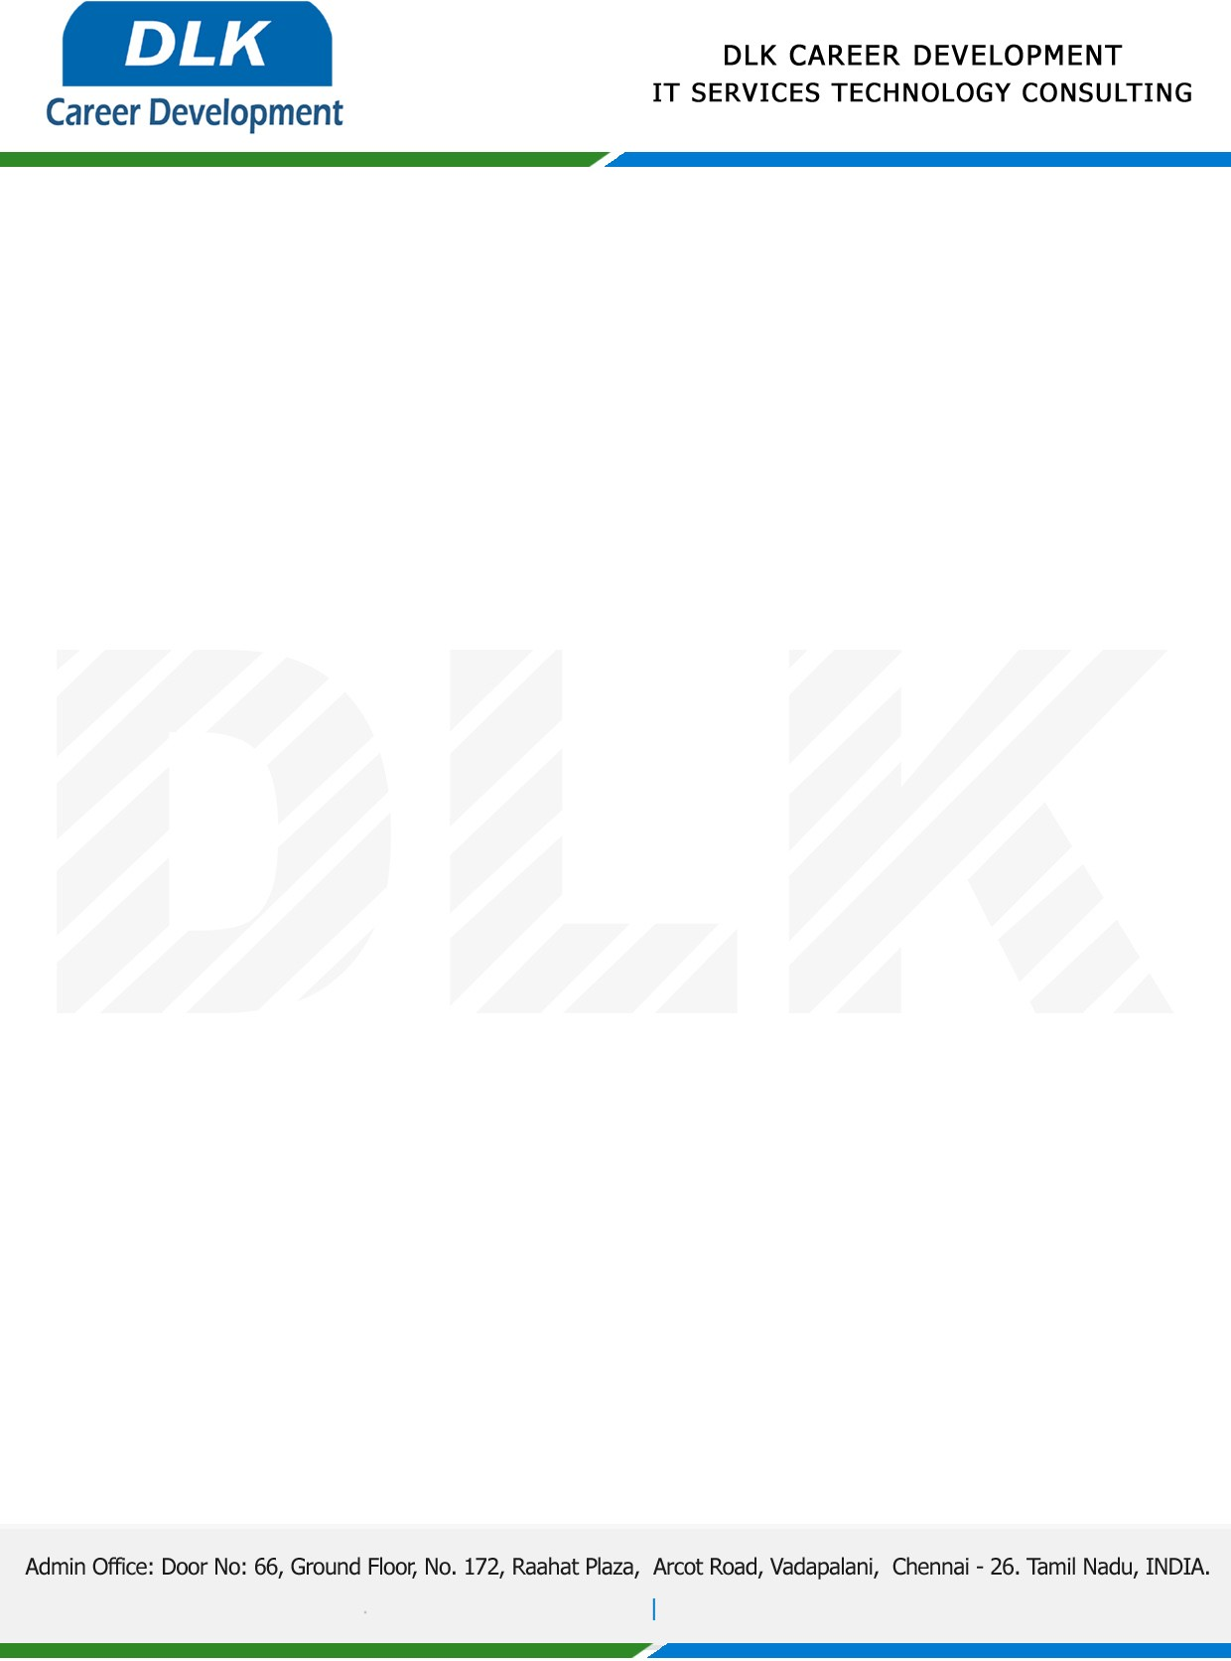

Date: 19 /May / 2023

**To**

Department of B.SC (Data Science),

Head of Department,

Sri Krishna Arts and Science College, Coimbatore- [641008](https://www.bing.com/maps?&mepi=103~~Unknown~Address_Link&ty=18&q=Sri%20Krishna%20Arts%20and%20Science%20College&ss=ypid.YN4070x8784236814389480601&ppois=10.93751335144043_76.95935821533203_Sri%20Krishna%20Arts%20and%20Science%20College_YN4070x8784236814389480601~&cp=10.937513~76.959358&v=2&sV=1).

**Sub: Letter of Internship Acceptance**

This is to certify that **MR AKASH A (REG NO:** **21BDS005 )** final year student of has accepted the internship Work duration from **05th June 2023** to **05th July 2023** under the domain **“Web Development”.** During the internship, all information and data collected from you should be kept confidential.

We appreciate your interest in **DLK CAREER DEVELOPMENT**

